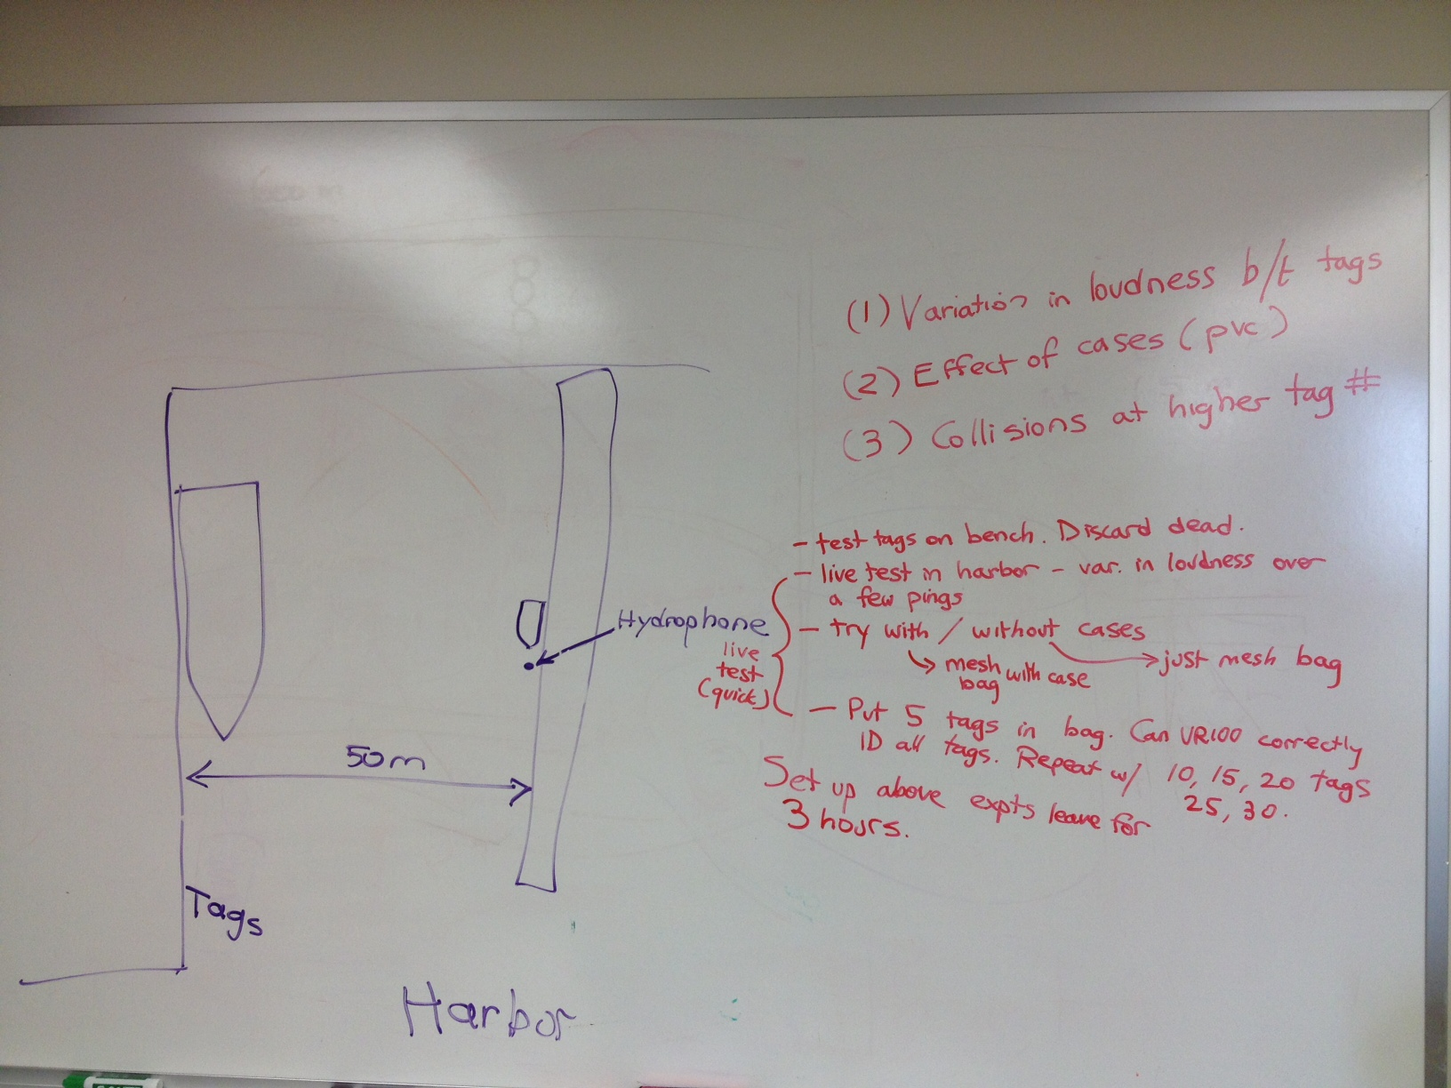
The other boat, the keala kai, is the white and blue one on
the floating dock.
Combo lock 7180.

Metal gate 0211.

Plastic shed 1842.

